PROJECT NEXUS

GROUP MEMBERS:
Muhammad Hammad Shakeel
Sikandar Khaleel
Aurshia Mudassar

MILESTONE | DATE | VERSION | REMARKS
ERD + SCHEMA | 24 / 4 / 2026 | V1.0

V1.0 - SCHEMA: 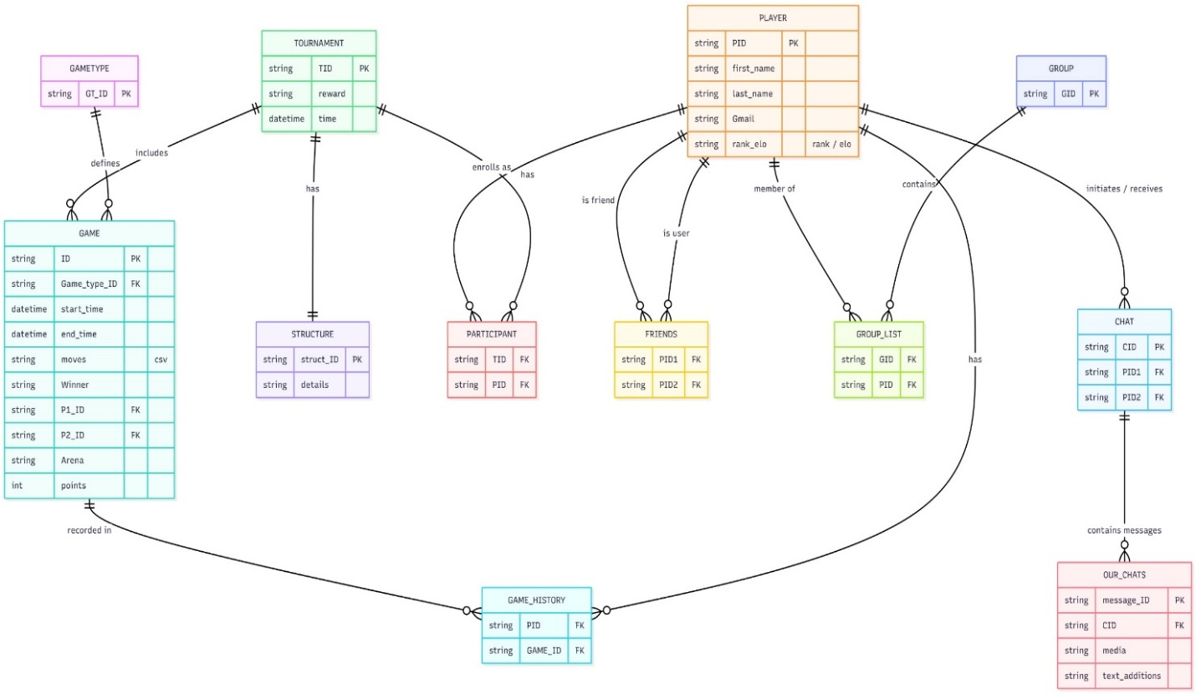

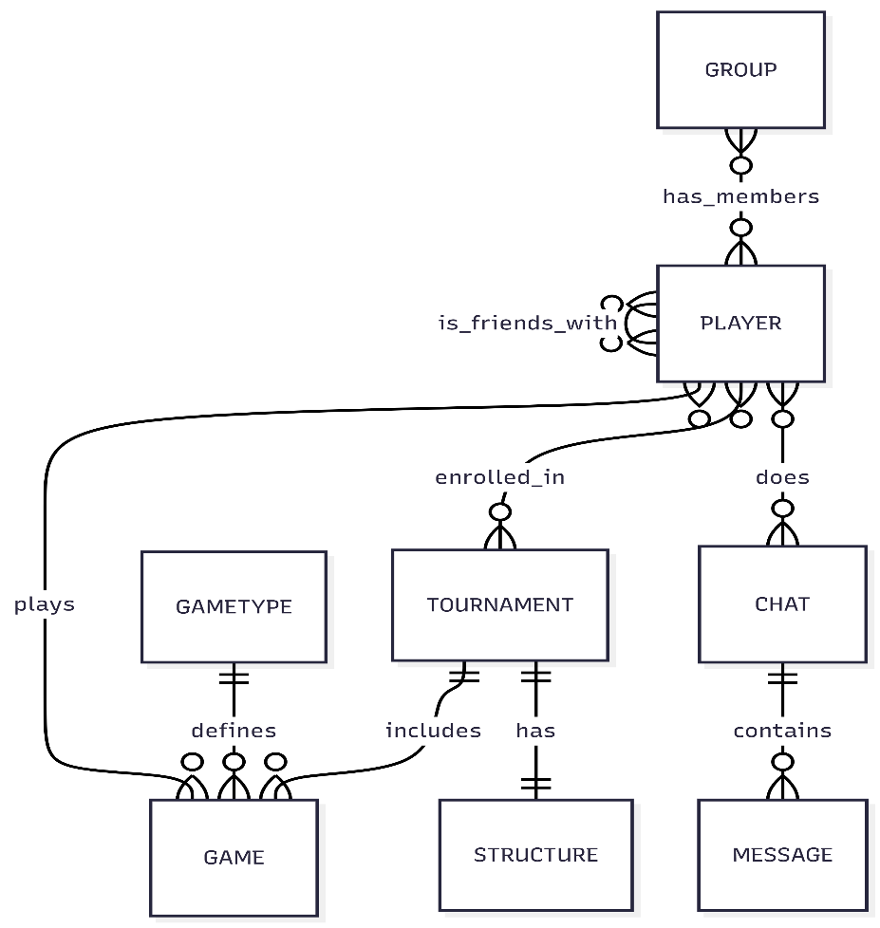
V1.0 - ENTITY RELATIONSHIP DIAGRAM:

